Assignment 1- SEVIR Dataset

| **Summary** | In this codelab, you will download and analyze the SEVIR dataset from aws using boto 3 module. You will analyze the Catalog: A CSV file with rows describing the metadata of an event and Data Files: A set of HDF5 files containing events for a certain sensor type.  The set of storm events files from NWS registry is visualized using GCP bucket, big query and Google data studio. The reports have been generated for various attributes contributing to the storm events. |
| --- | --- |
| **URL** | https://codelabs-preview.appspot.com/?file_id=1a15lLYAxzjThC4sFioo2zqqEymSbLbNCMd3vF4aSHlM#0 |
| **Category** | Web |
| **Environment** | Jupyter notebook, Google data studio, Big query, GCP bucket |
| **Status** | Published |
| **Feedback Link** |  |
| **Author** | Mayuri More, Nishanth Reddy Kogilathota, Romita Thally |
| **Author LDAP** | Mayuri |
| **Analytics Account** |  |

Introduction to SEVIR Dataset

Downloading SEVIR

Using boto3 modules :

SEVIR Tutorial

Accessing the SEVIR data from local storage :

Accessing a specific event with event ID by opening data file directly without using the catalog

Accessing all available sensor data for a particular event

Using rows of sample_event to extract image data for each type

Including Lightning by converting the flash data into flash counts per pixel per 5 minute frame

Adding Color using colormaps

Georeferencing an Event

Adding markers for particular locations by converting from lat/lon coordinates into the image pixel coordinates

GCP and Bigquery

Adding datasets to GCP bucket

Creating tables using Big Query.

Connecting the Google data studio via big query to generate reports and visualize the data.

# Introduction to SEVIR Dataset

The Storm EVent ImagRy (SEVIR) dataset is a collection of temporally and spatially aligned images containing weather events captured by satellite and radar. This dataset was created using publically available datasets distributed by NOAA, including the [GOES-16 geostationary satellite](https://registry.opendata.aws/noaa-goes/), and data derived from [NEXRAD weather radars](https://registry.opendata.aws/noaa-nexrad/), both of which are available on the Registry of Open Data on AWS. This tutorial provides information about the SEVIR dataset as well as code samples that can be used to access the data.

There is no shortage of weather data available to the public: Weather radar, GEO & LEO satellite, surface observations, numerical weather prediction models, balloons, ocean buoys, aircraft measurements, lightning sensing, radio occultation, and others are being measured every second of every day to aid in our ability to analyze and forecast the weather. As a result, both the size and complexity of all of this data can make it difficult to work with. Many datasets, such as radar and satellite, are too large to process in bulk for those without access to massive compute and storage. Some datasets also require a level of domain expertise to decode, understand and process. These are some of the barriers for scientists and researchers who want to understand and use this data for their applications.

To help alleviate these issues, the SEVIR dataset was constructed to enable faster R&D in weather sensing, avoidance, short-term forecasting and other related applications. SEVIR combines and aligns multiple weather sensing modalities into a single, accessible dataset accessible for free on the cloud that can be used by meteorologists, data scientists and other researchers.

SEVIR is a collection of thousands of "events", which are 4-hour sequences of weather captured by up to 5 sensors. These 5 sensing modalities are summarized in the table below:

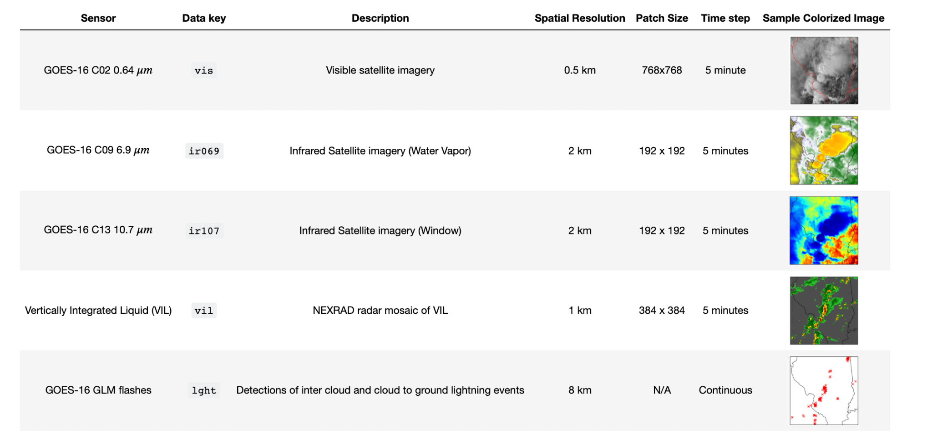

# Downloading SEVIR

### **Using boto3 modules :**

Downloading CSV and HDF5 files from aws s3 using boto 3 modules

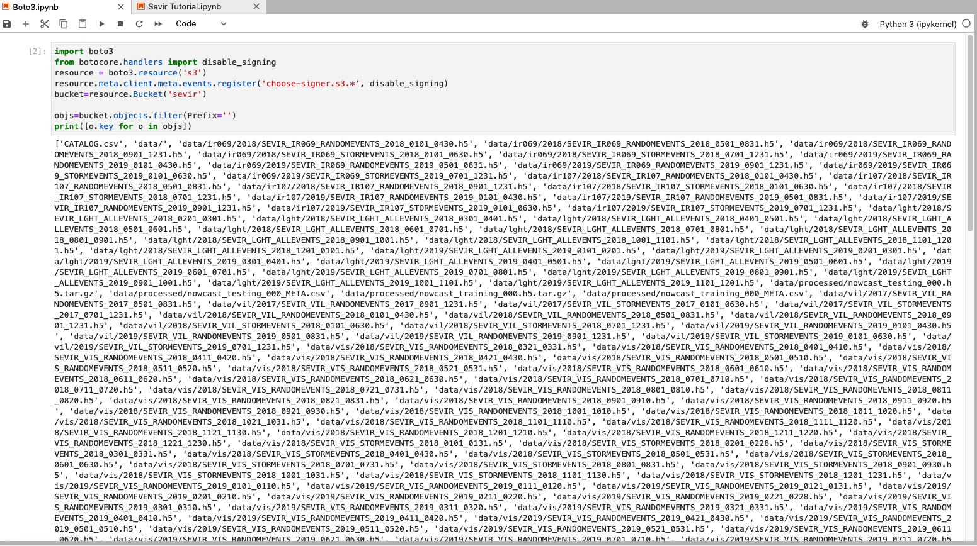

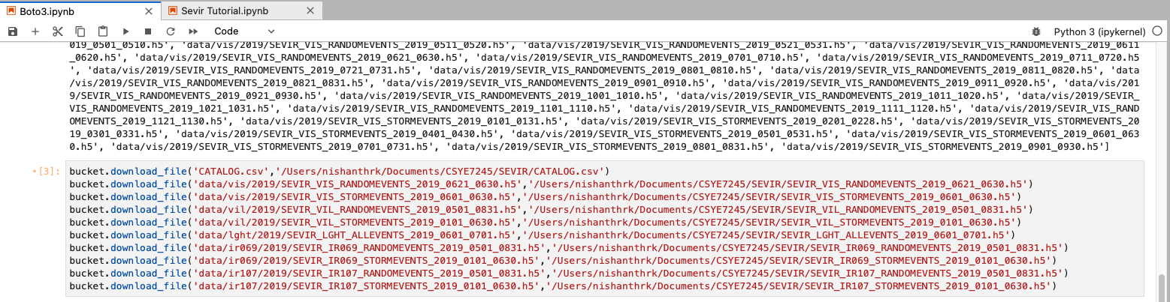

# SEVIR Tutorial

## Accessing the SEVIR data from local storage :

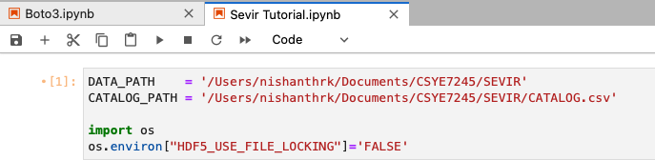

## Accessing a specific event with event ID by opening data file directly without using the catalog

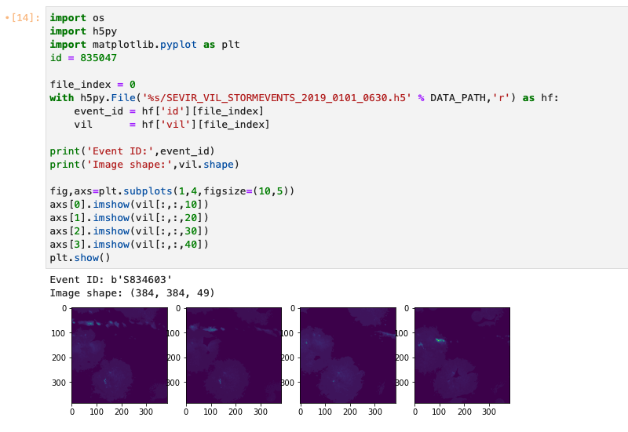

## Accessing all available sensor data for a particular event

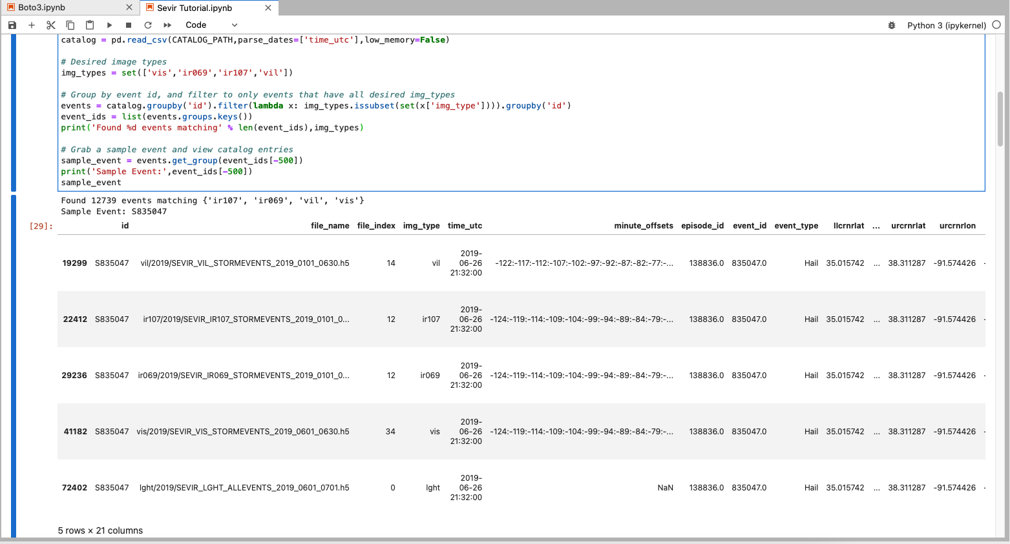

## Using rows of sample_event to extract image data for each type

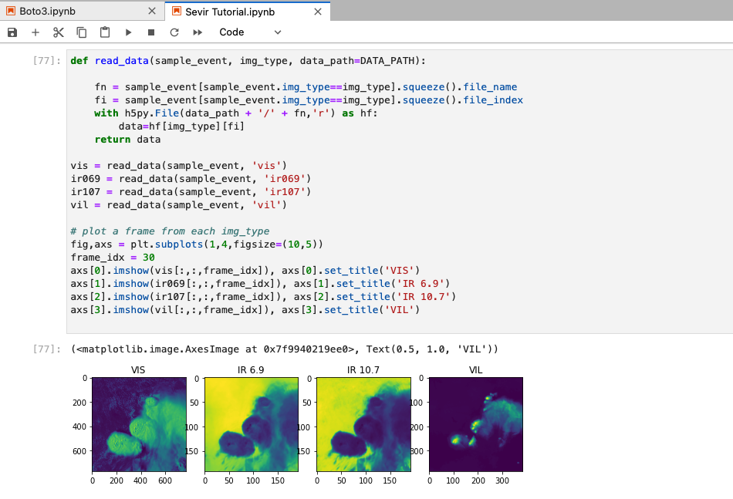

## Including Lightning by converting the flash data into flash counts per pixel per 5 minute frame

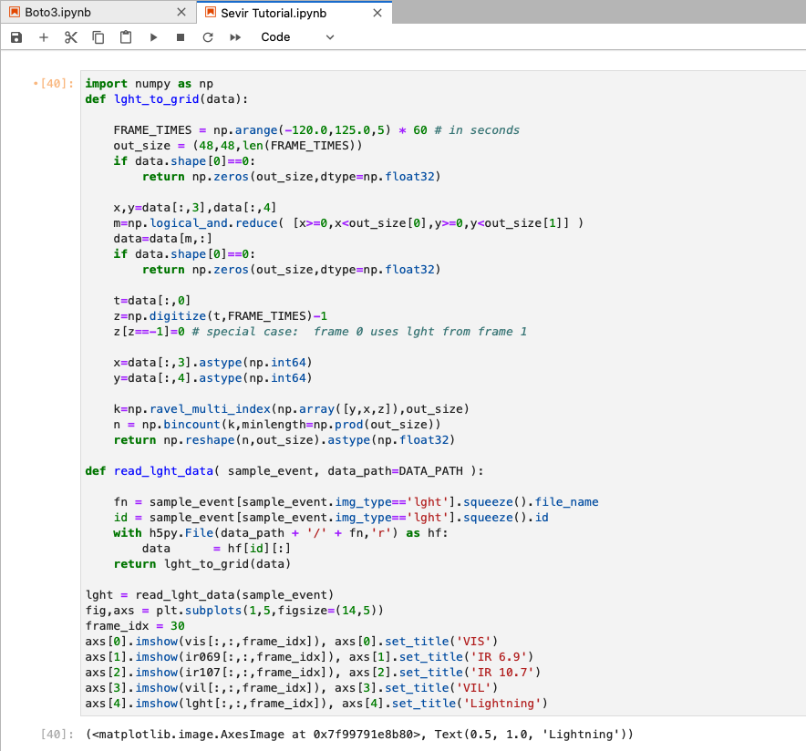

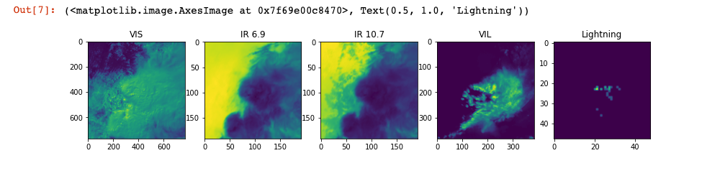

## Adding Color using colormaps

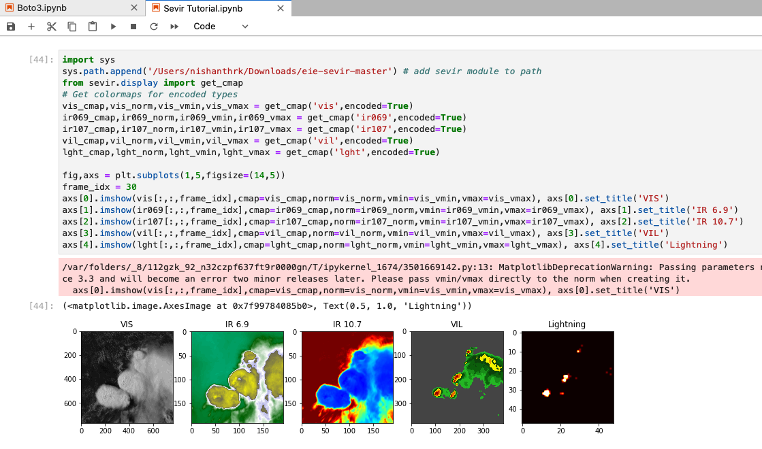

## Georeferencing an Event

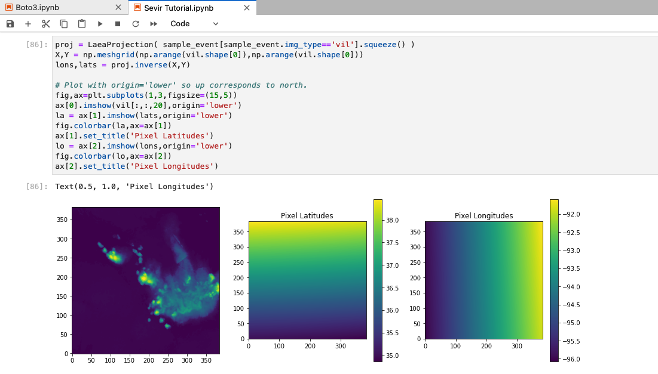

## Adding markers for particular locations by converting from lat/lon coordinates into the image pixel coordinates

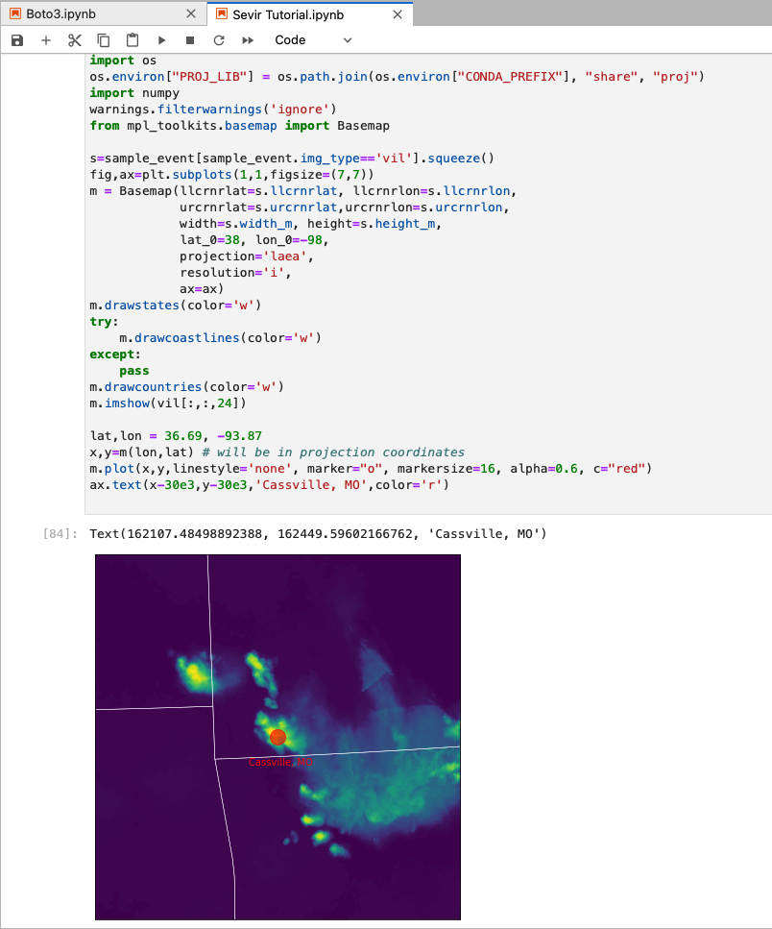

# GCP and Bigquery

## Adding datasets to GCP bucket

Catalog.csv and 2019 storm events files are added to the GCP bucket.

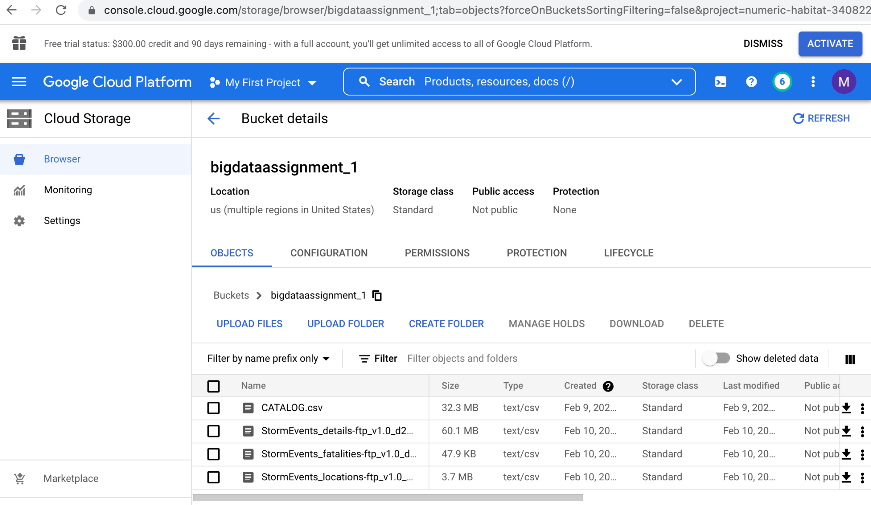

## Creating tables using Big Query.

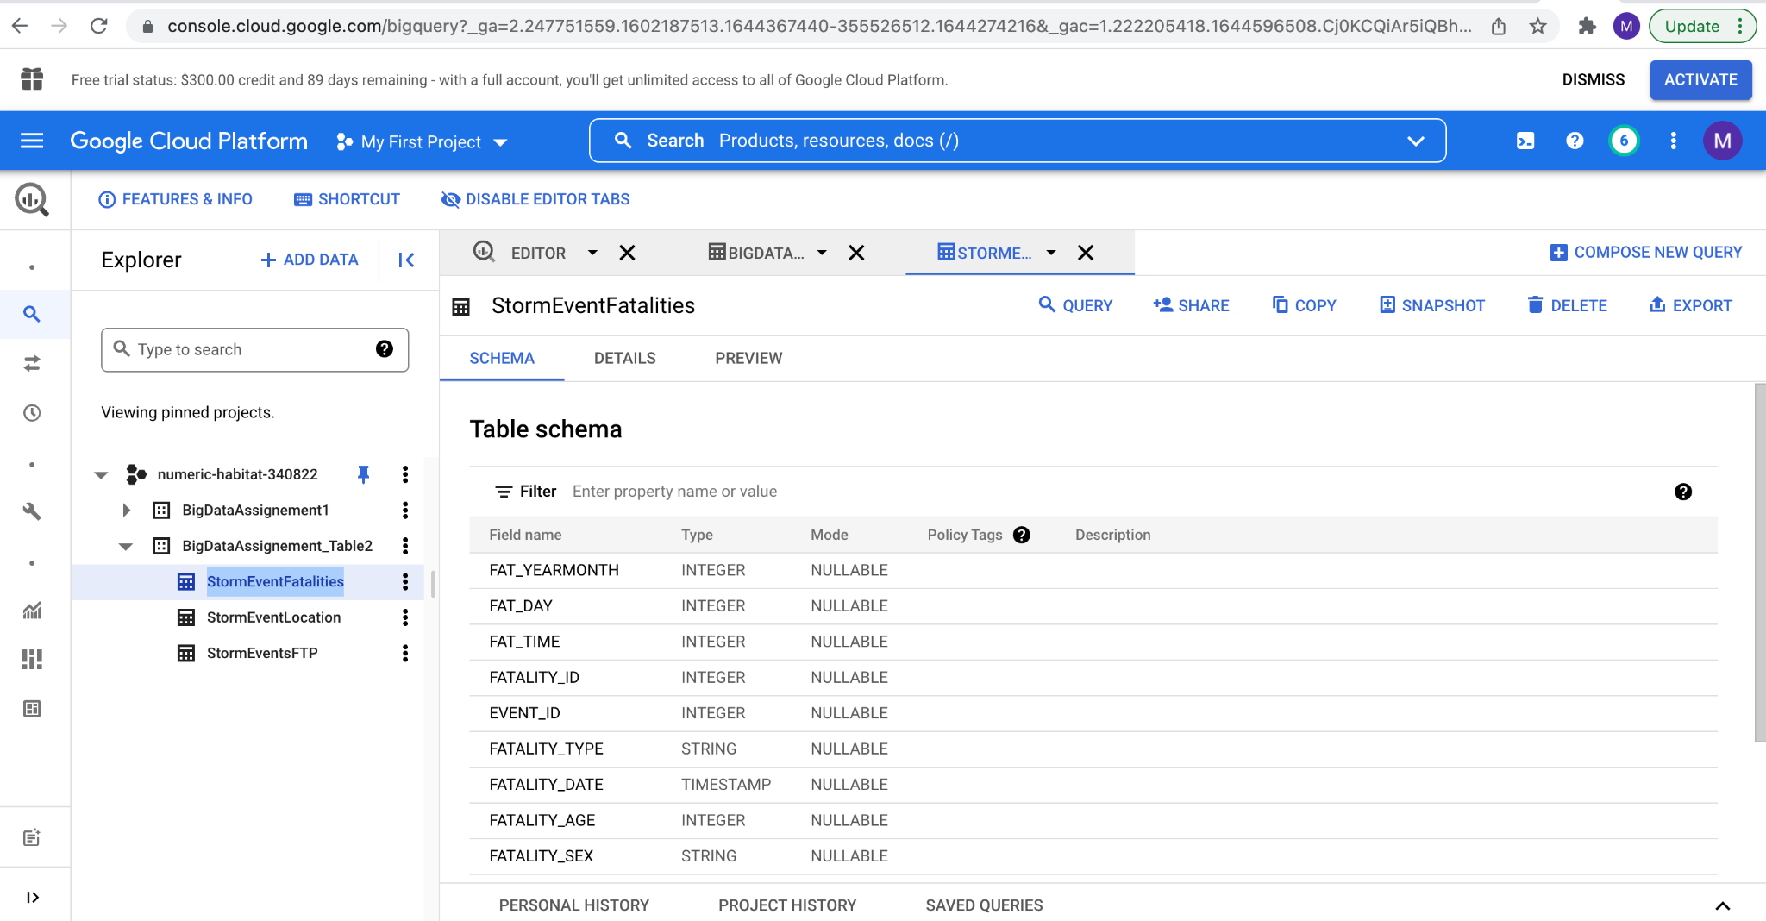

## 

## 

## 

## 

## 

## 

## 

## Connecting the Google data studio via big query to generate reports and visualize the data.

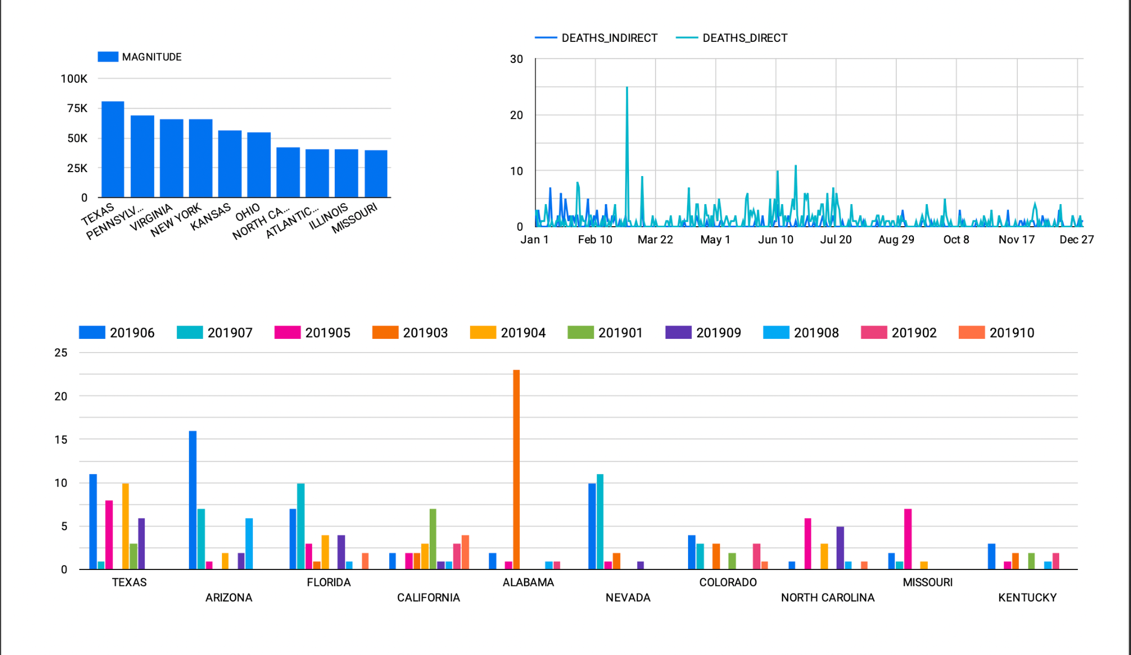

These graphs are generated for the StormEventsFTP file.

1. The first bar chart represents the magnitude of storm events in each state.
2. The second time series chart represents the count of deaths directly caused by storms and indirectly caused by storms over a time period of a year.
3. The third combo chart represents the death count in each state for every month in the year 2019.

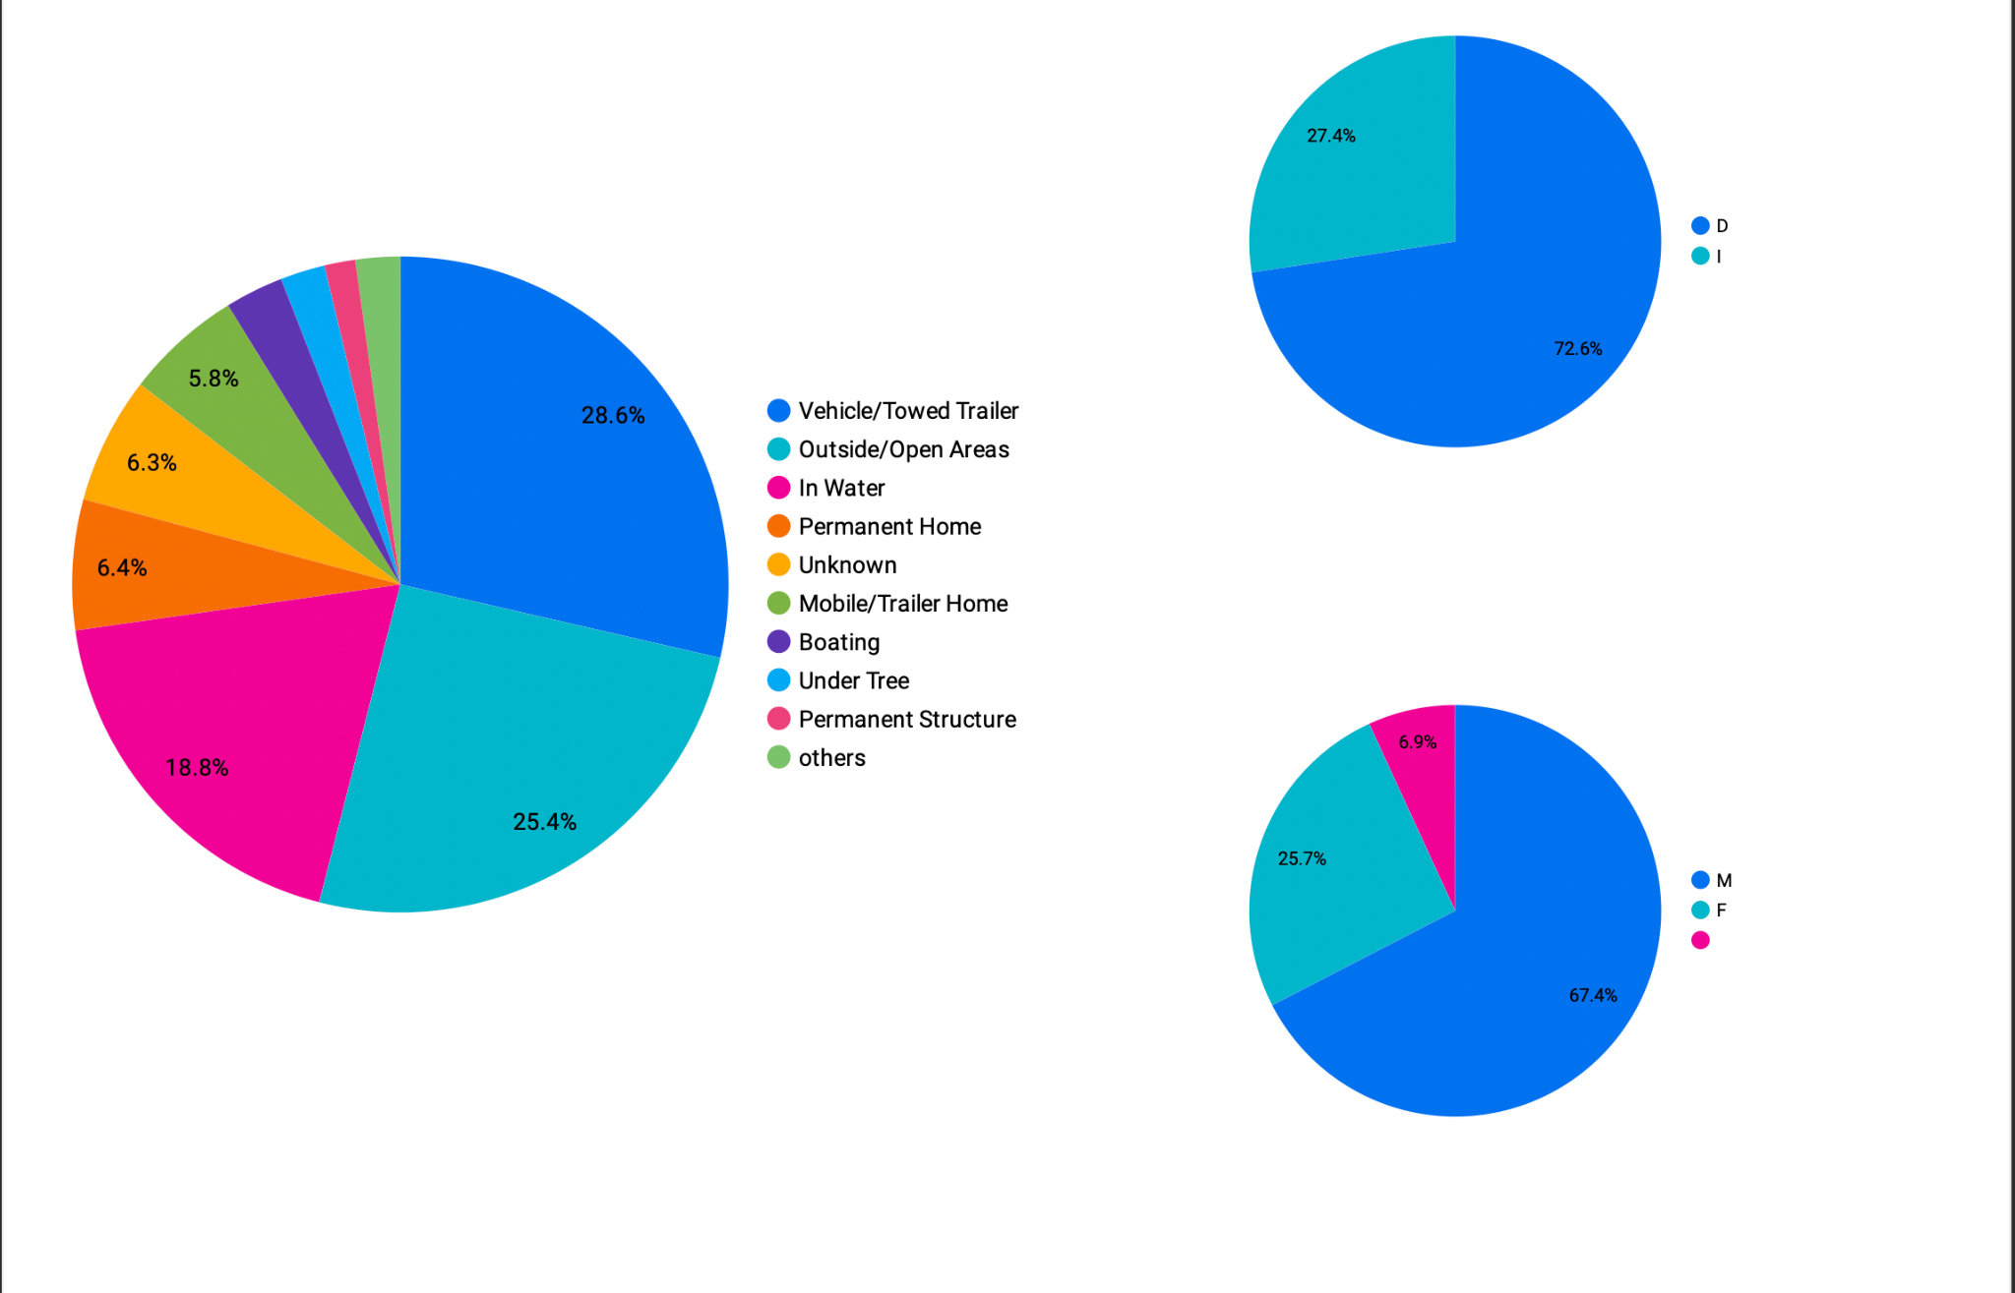

These graphs are generated for the StormEventsfatalities file.

1. The first pie chart represents the area where the fatalities have happened. We can see that apporx 28.6% of the population which was using vehicles or towed trailers were injured during storm events.
2. The second Pie chart represents the direct fatality caused by storm and the indirect fatality caused by storm. We can see that the direct fatality is larger in the number.
3. The third pie chart represents the gender of the people affected during the storm.